

METROPOLITAN DETROIT MEDICAL LIBRARY GROUP (MDMLG)

ARCHIVIST
Annual Report
2011 - 2012

OBJECTIVES:
- Make timely deposits of materials as received from the membership to the Reuther Library of Labor and Urban Affairs..
- Seek out archival material which is lacking or will enhance the collection
- Keep the membership aware of the material at the Reuther Library and its availability. To publish/post information about the archives to membership
- Publicize the material in the Walter P. Reuther Library to appropriate non-MDMLG groups and individuals;
- Maintain contact with the archivist responsible for the MDMLG materials at the Reuther Library;
- To arrange for at least one visit during the year and to investigate developing current finding aids for the collection

ACCOMPLISHMENTS:
- Gathered committee and officer documents.
- Contacted, Kathleen Schmeling, Acting Director, to confirm service charges and invoicing . No annual charges accrued during the year 2011 0 2012.

__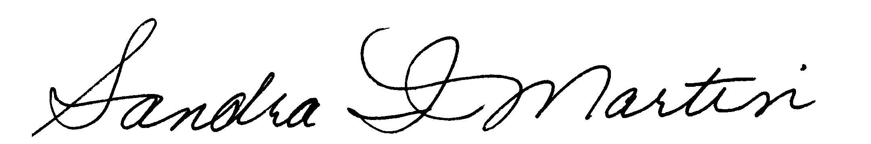_______ June 1, 2012
Sandra I. Martin, ARCHIVIST DATE

